

**PROJECT -1**

**Project : 3 Tier Architecture for a WEB Application in AWS**

-Nikhita Indu Kovvuri

-Batch 122

[nikhithaindu@gmail.com](mailto:nikhithaindu@gmail.com)

9390046899

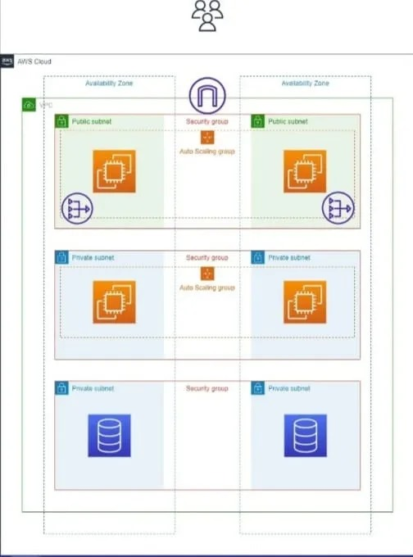

* Create VPC and connect subnets through Auto scaling and connect RDS
* Search VPC
* Click on Create VPC
* Enter VPC Name and enter CIDR Number then Click on create VPC

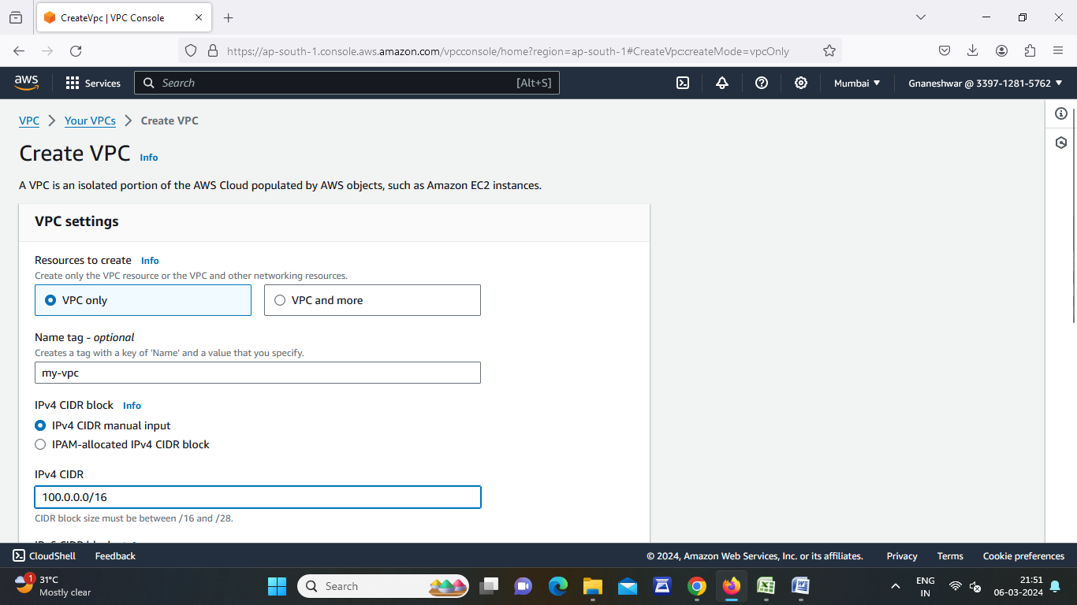

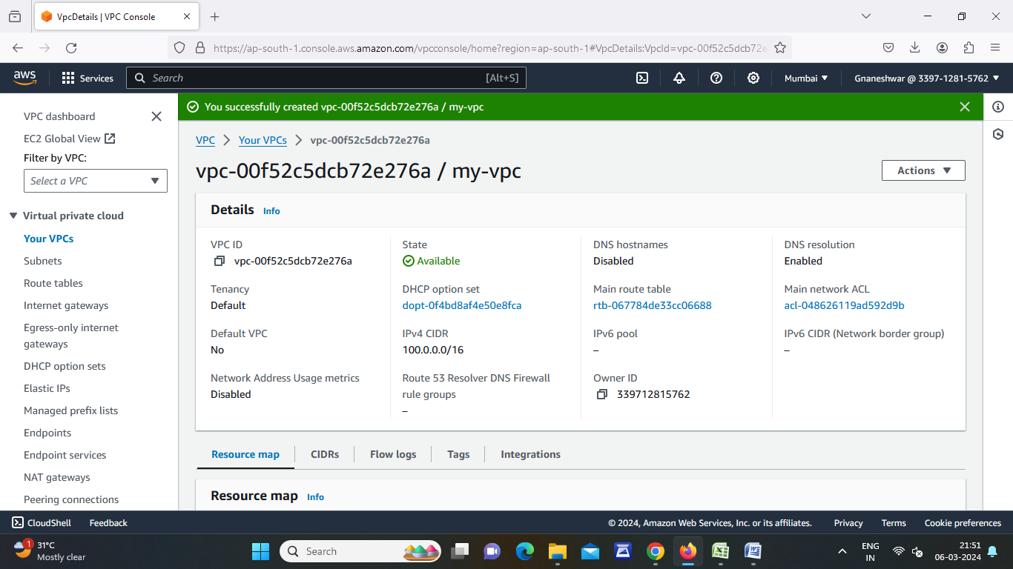

* Go to Subnets and Click on create 2 public Subnets
* Select our VPC then enter Public subnet name and select One region then ipv4 subnet CIDR Number
* Click on add new subnet

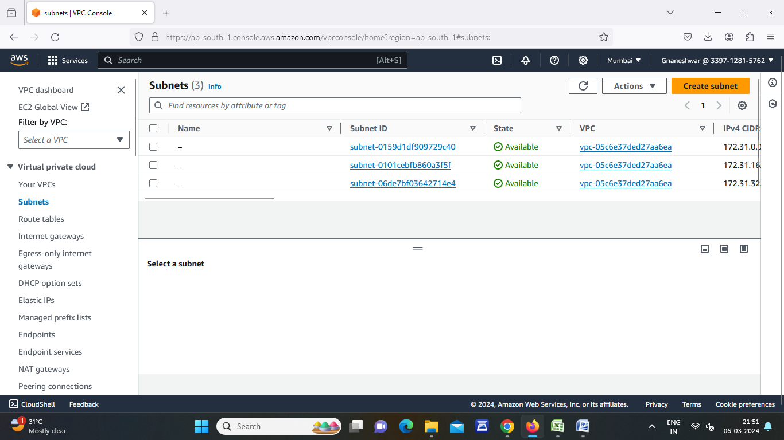

* Enter public subnet name and select another region then ipv4 subnet CIDR Number then Click on Create Subnet

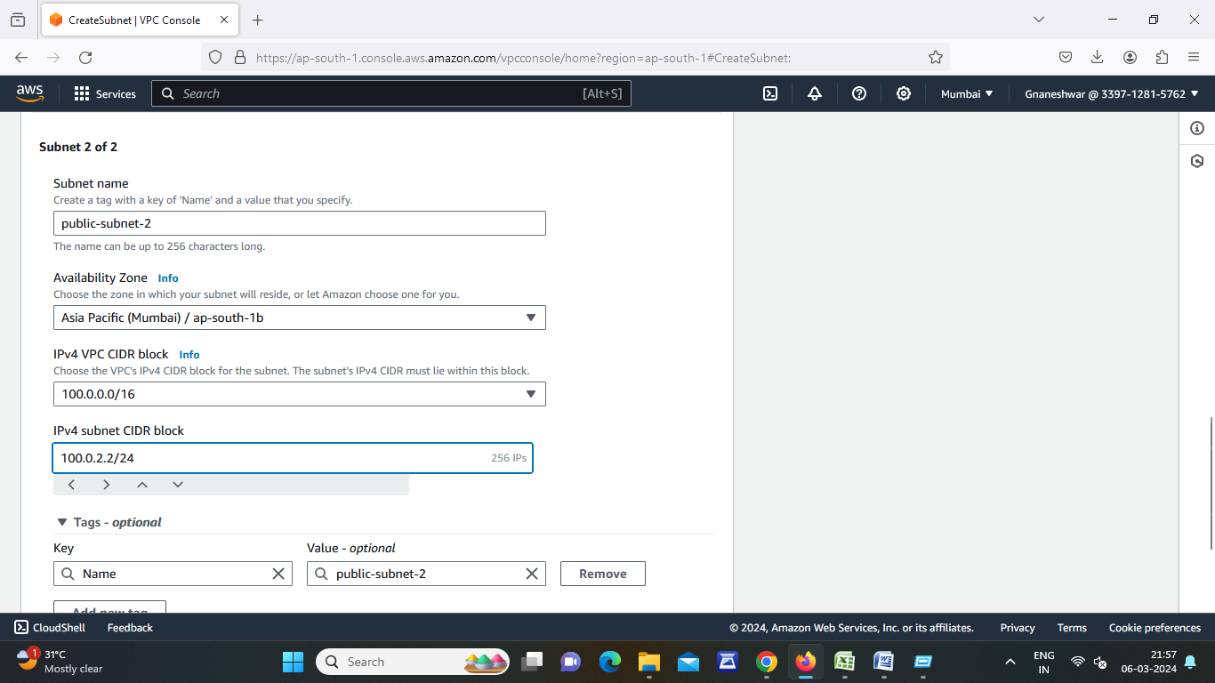

* Go to Subnets and Click on create 2 Private Subnets
* Select our VPC then enter Private subnet name and select One region then ipv4 subnet CIDR Number
* Click on add new subnet

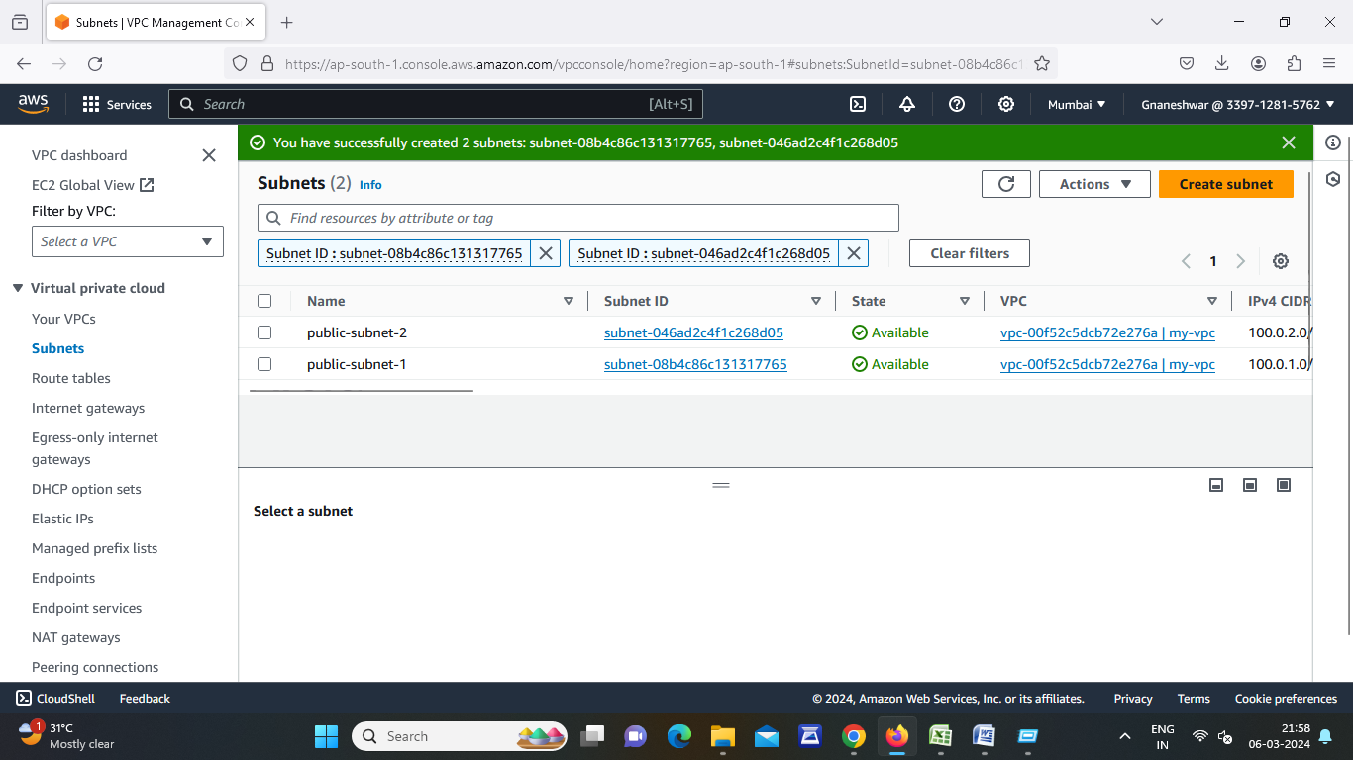

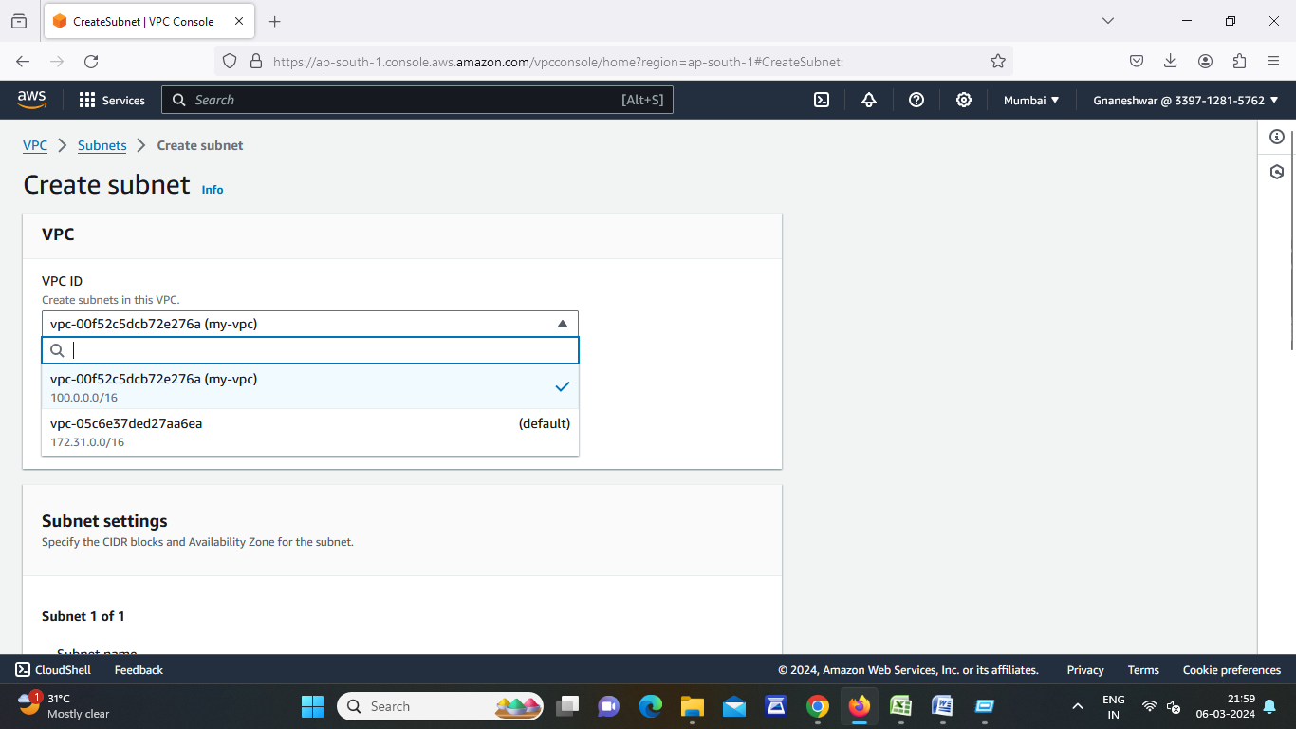

* Enter public subnet name and select another region then ipv4 subnet CIDR Number then Click on Create Subnet
* After Successfully created public and private go to route tables

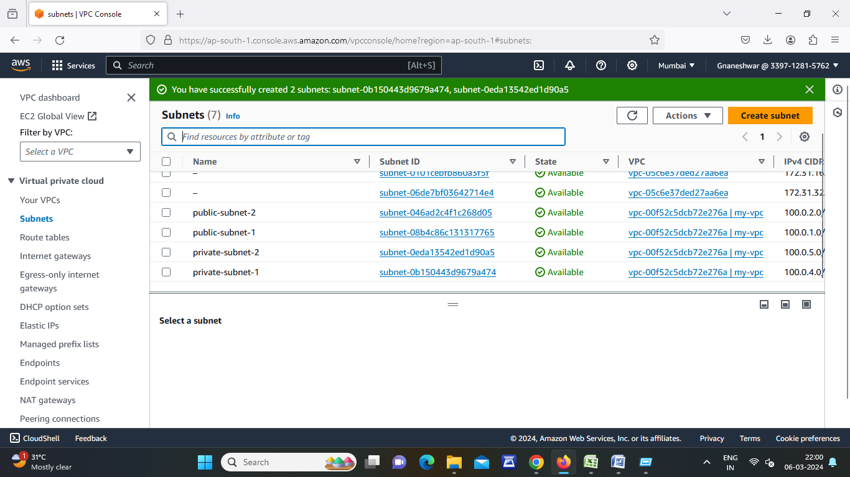

* Create 2 route tables (public and private)
* Click on create route table
* Enter route table name for public then select our VPC then click on create route table
* Enter route table name for private then select our VPC then click on create route table
* Click on Public route table id then go to subnet association
* Go to edit subnet association select public subnets then save changes.

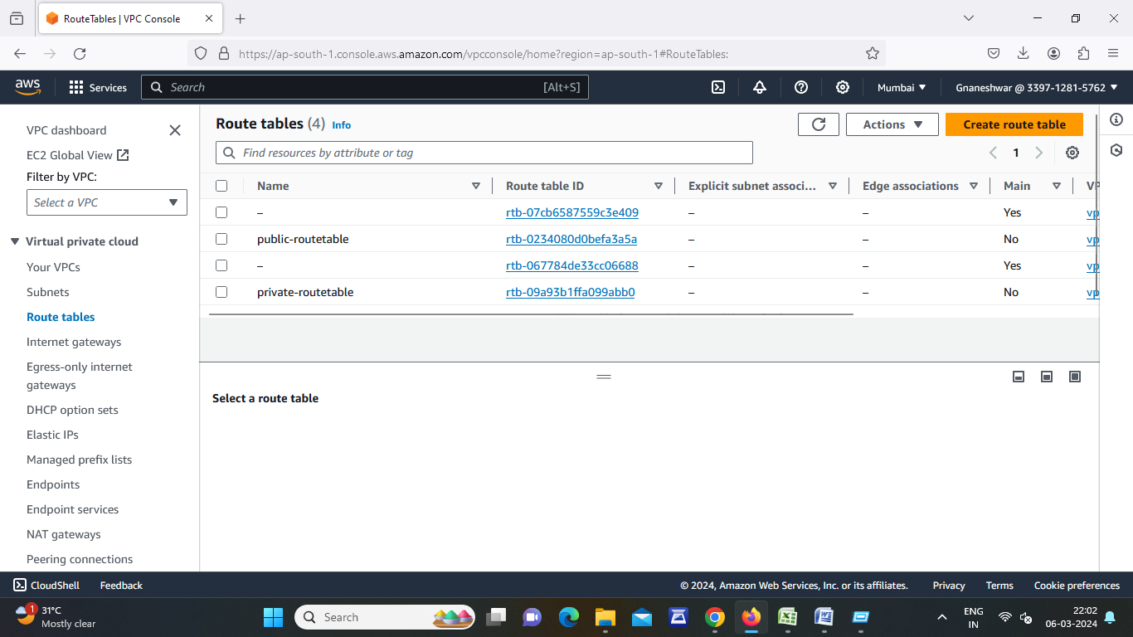

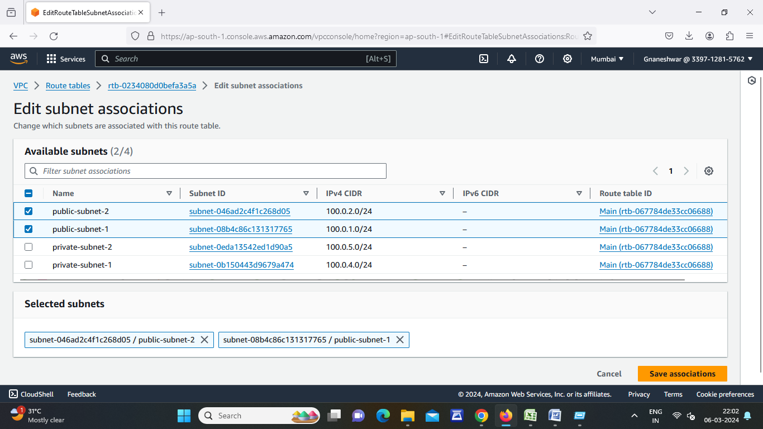

* Click on Private route table id then go to subnet association
* Go to edit subnet association select private subnets then save changes.

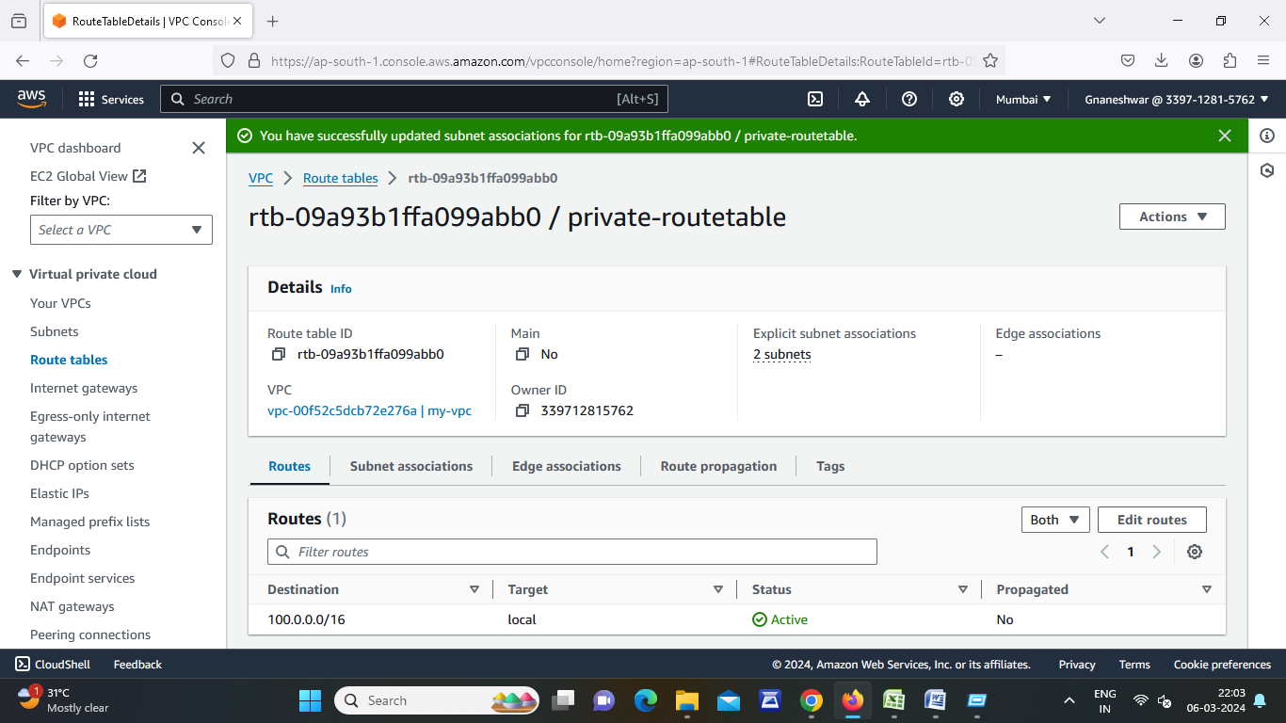

* Now go to Internet gateway then click on create internet gateway
* Enter internet gateway name then click on create internet gateway

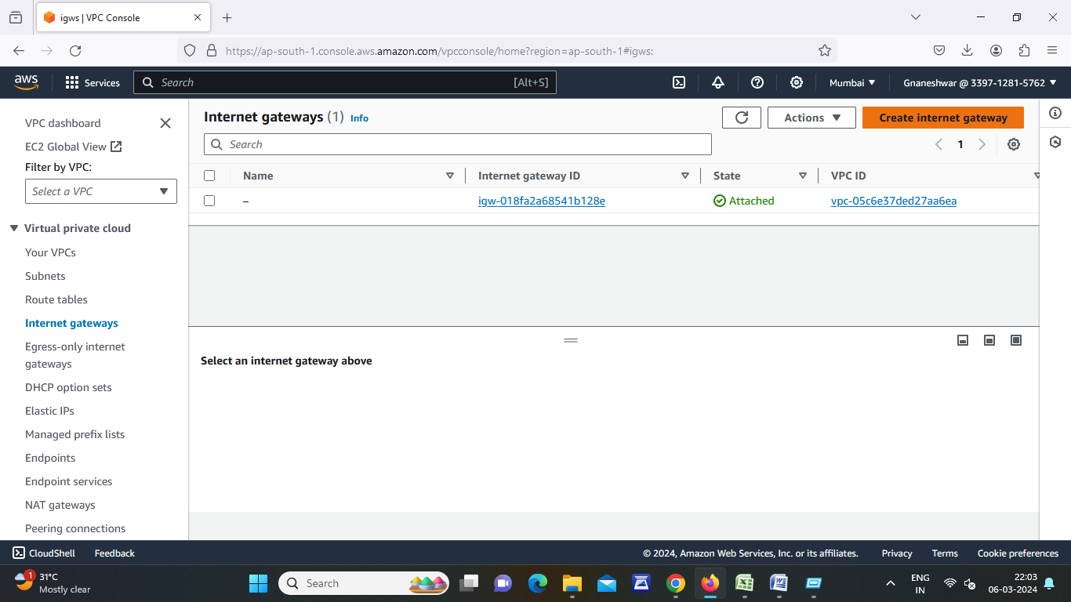

* Go to actions then attach to VPC
* Select our VPC then click on attach internet gateway
* Go to NAT Gateway

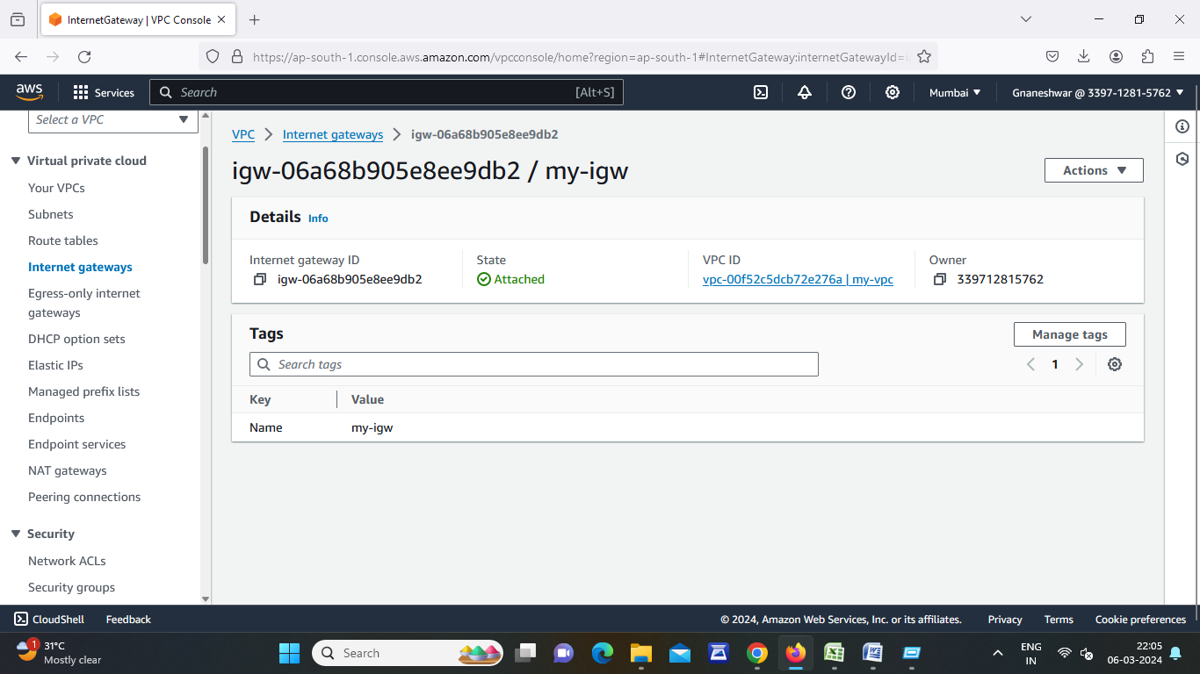

* Click on create NAT gateway
* Enter Name and select public subnet then click on allocate elastic ip then click on create NAT gateway

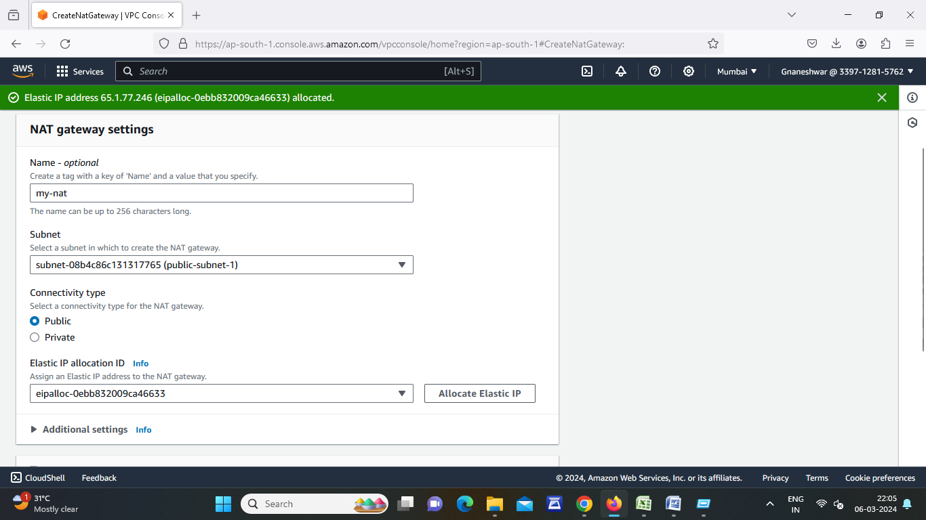

* Go to Route Tables and add routes to the tables
* Click on Public route table id then go to actions
* Click on edit routes
* Click on add route select Destination 0.0.0.0/0
* Select target group is Internet gateway and NAT gateway then click on save changes

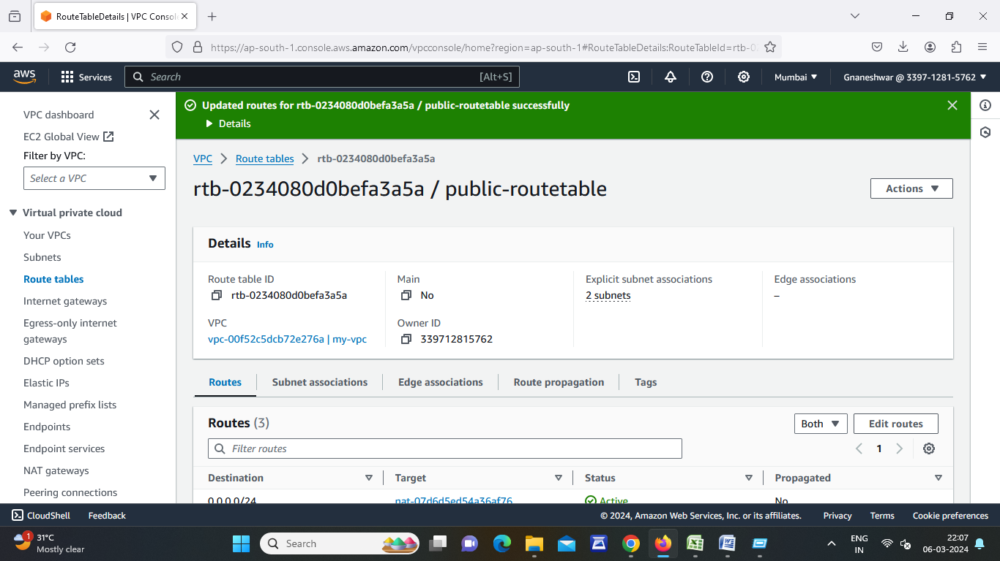

* Click on Private route table id then go to actions
* Click on edit routes
* Click on add route select Destination 0.0.0.0/0
* Select target group is NAT gateway then click on save changes

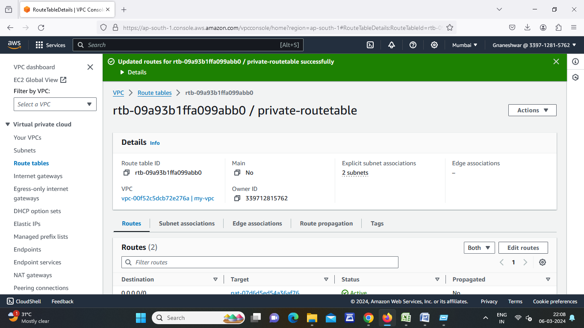

* Click on EC2 instance
* Click on Instances and click on launch instance
* Instance name then select AMI, instance type
* Click on create key pair then enter key name then click on create key pair
* Edit network settings select our VPC and select public subnet and enable auto assign ip
* Click on launch instance

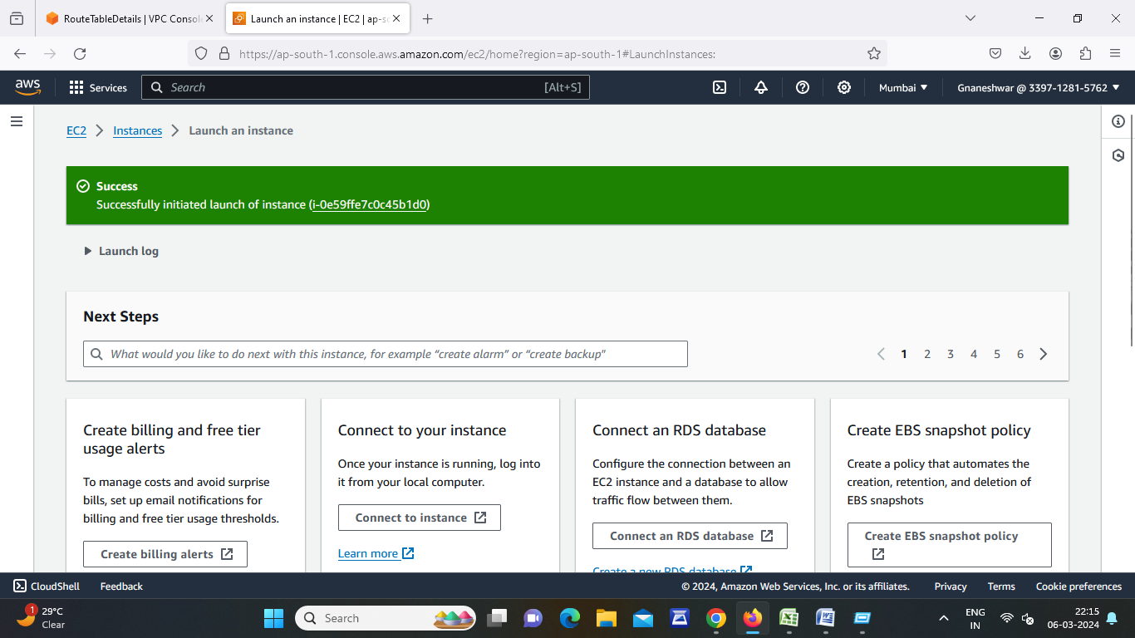

* Click on Check box Created EC2 instance go to actions then image and templates and create image.
* Enter name then click on create image.

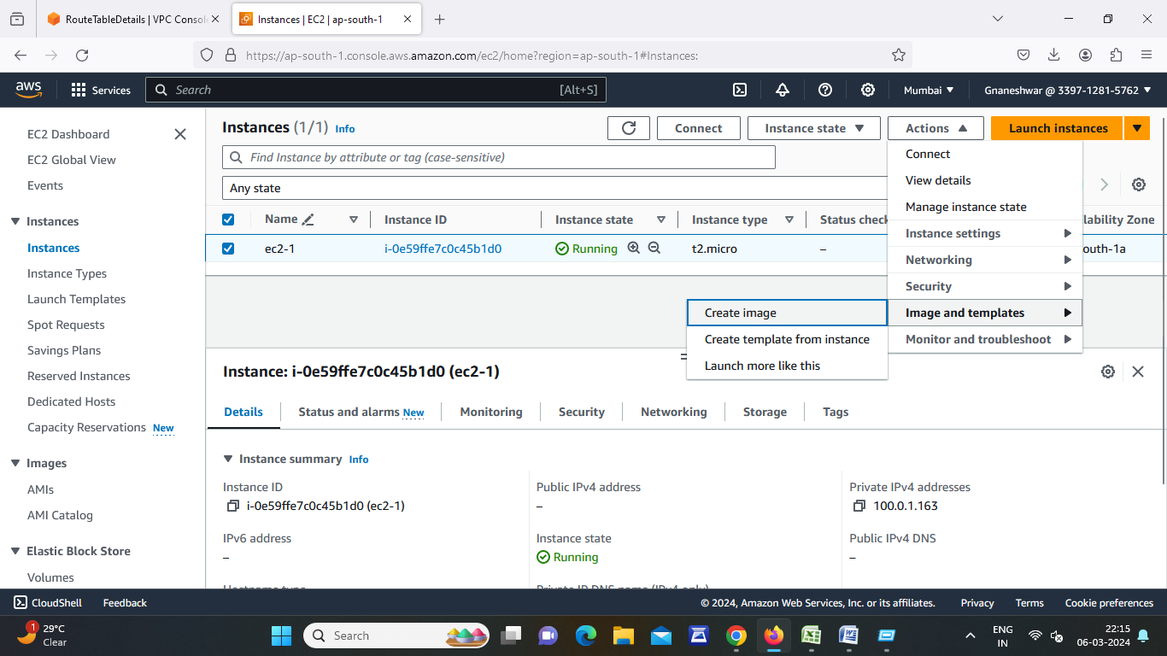

* Go to Auto scaling group
* Click on create auto scaling group
* Click on launch template
* Enter launch template name then select our created AMI, instance type, key pair and select security group then click launch template.

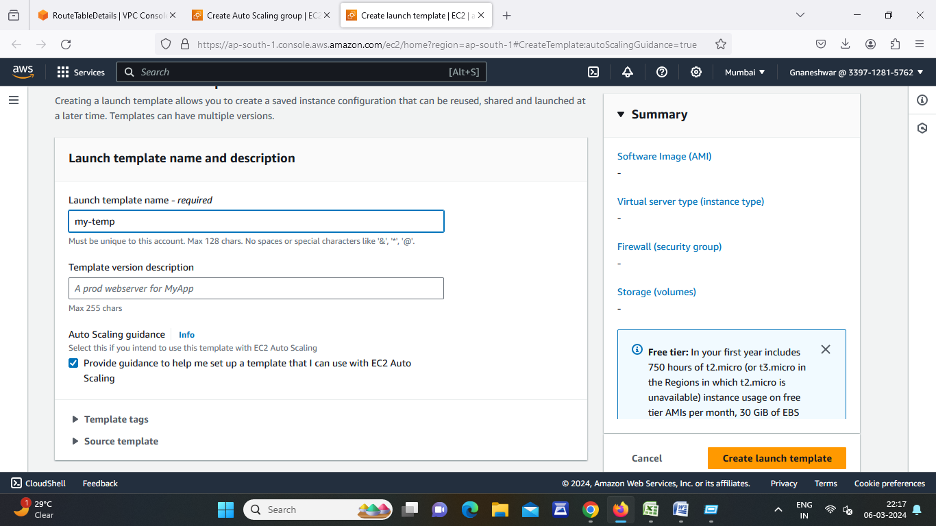

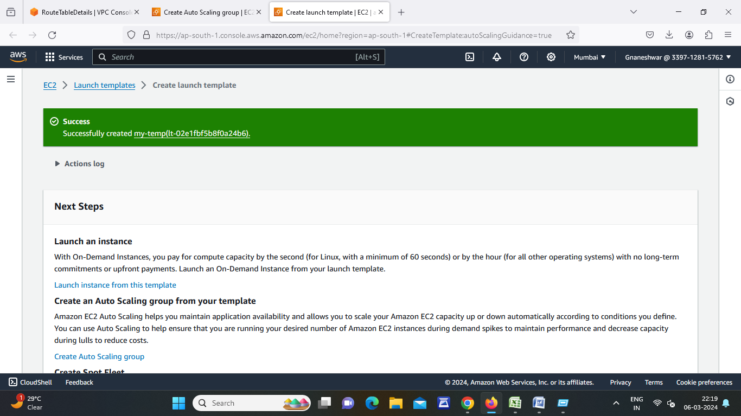

* Go auto scaling group and enter name
* Select our launch template then click on next
* Select our VPC and select public available zones then click on next
* Set time 60 sec then click on next
* Enter Desired Capacity then enter min and max desired capacity then click on next
* Click on Add notification and create topic
* Enter topic name and enter email id then next
* Click on create auto scaling group

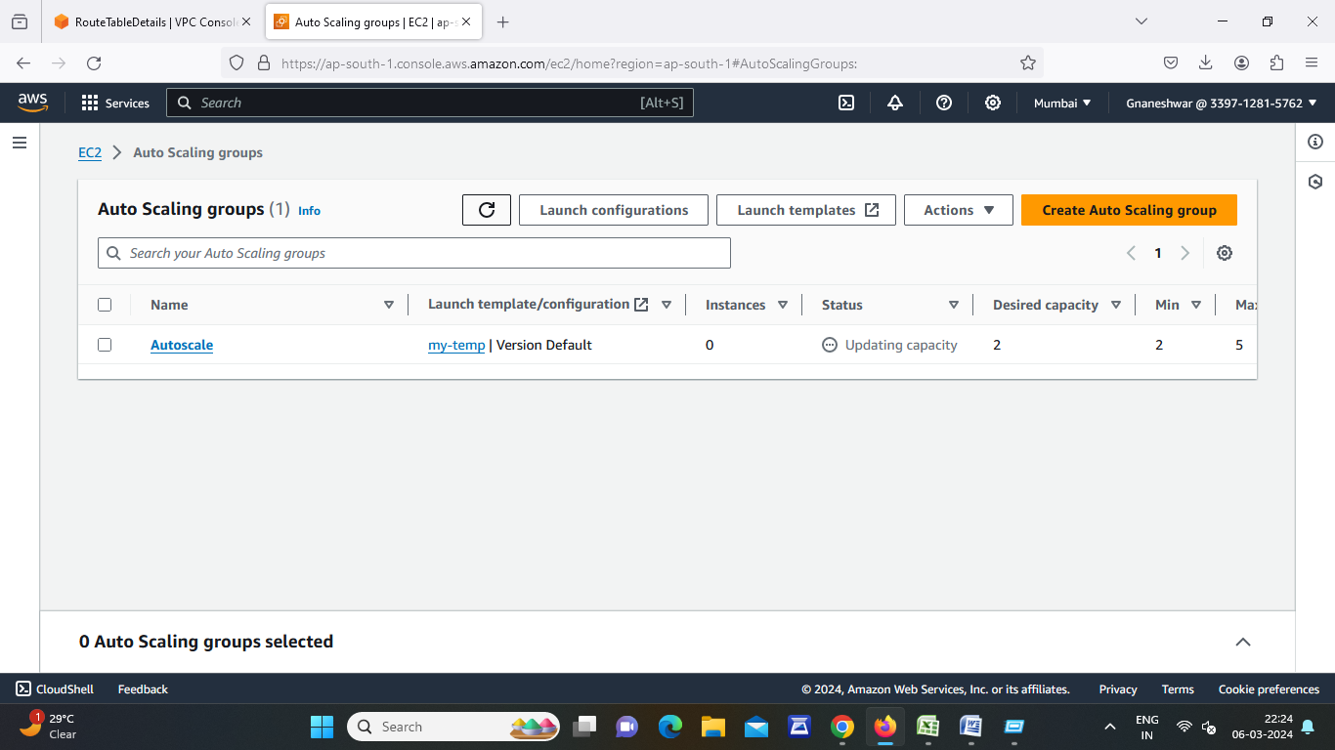

* Click on create auto scaling group
* Go auto scaling group and enter name
* Select our launch template then click on next
* Select our VPC and select public available zones then click on next
* Set time 60 sec then click on next

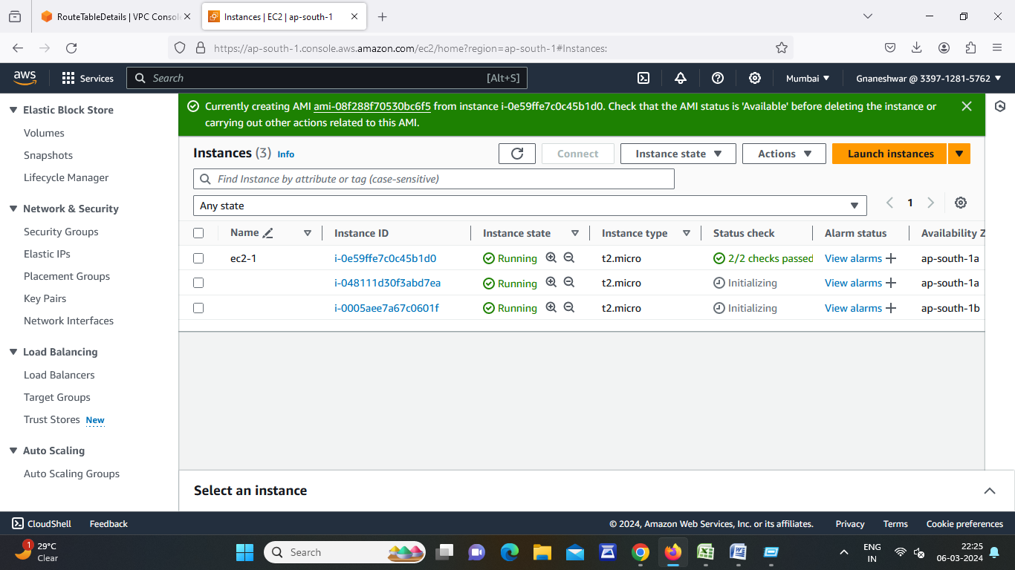

* Enter Desired Capacity then enter min and max desired capacity then click on next
* Click on Add notification and create topic
* Enter topic name and enter email id then next
* Click on create auto scaling group.

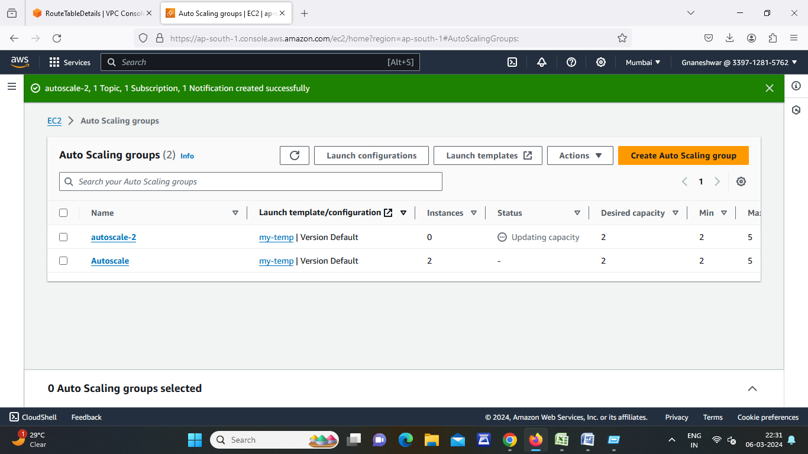

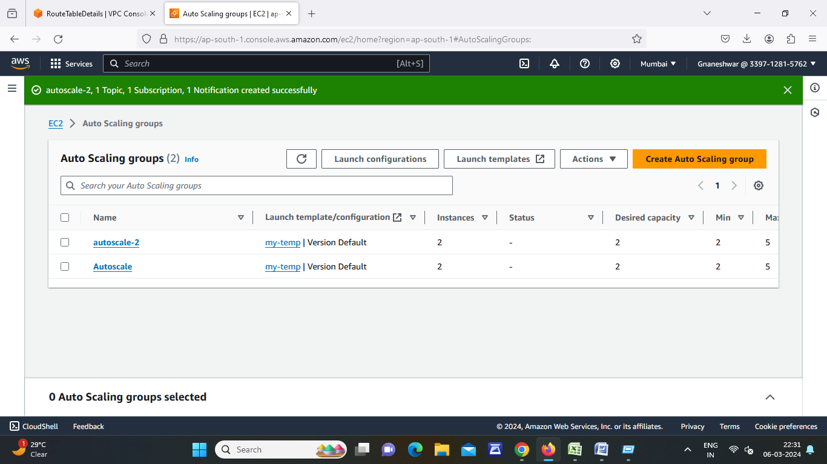

* After Creating Auto scaling group we can see the servers automatically created.
* Now go to VPC and create private subnets for RDS
* Now go to RDS
* Go to subnet groups then click on Create Subnet group
* Enter subnet group name and select VPC
* Select AZ’s then Select subnet’s RDS and public subnet of while launching ec2 instance of subnet.

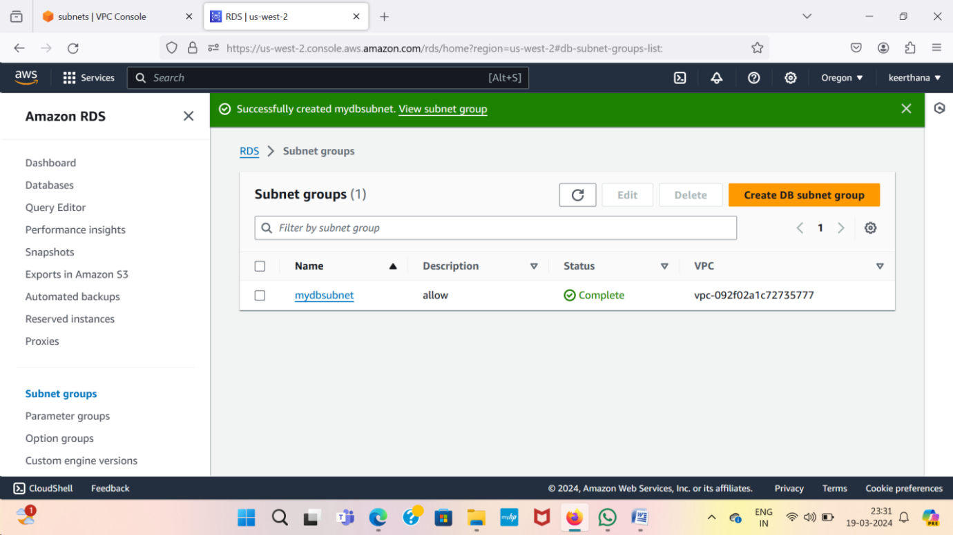

* Now go to Database
* Click on Create database through VPC and subnet group
* Now click on database then set up ec2 connection
* Click on set up ec2 connection and select ec2 instance click on next
* Then click on set up

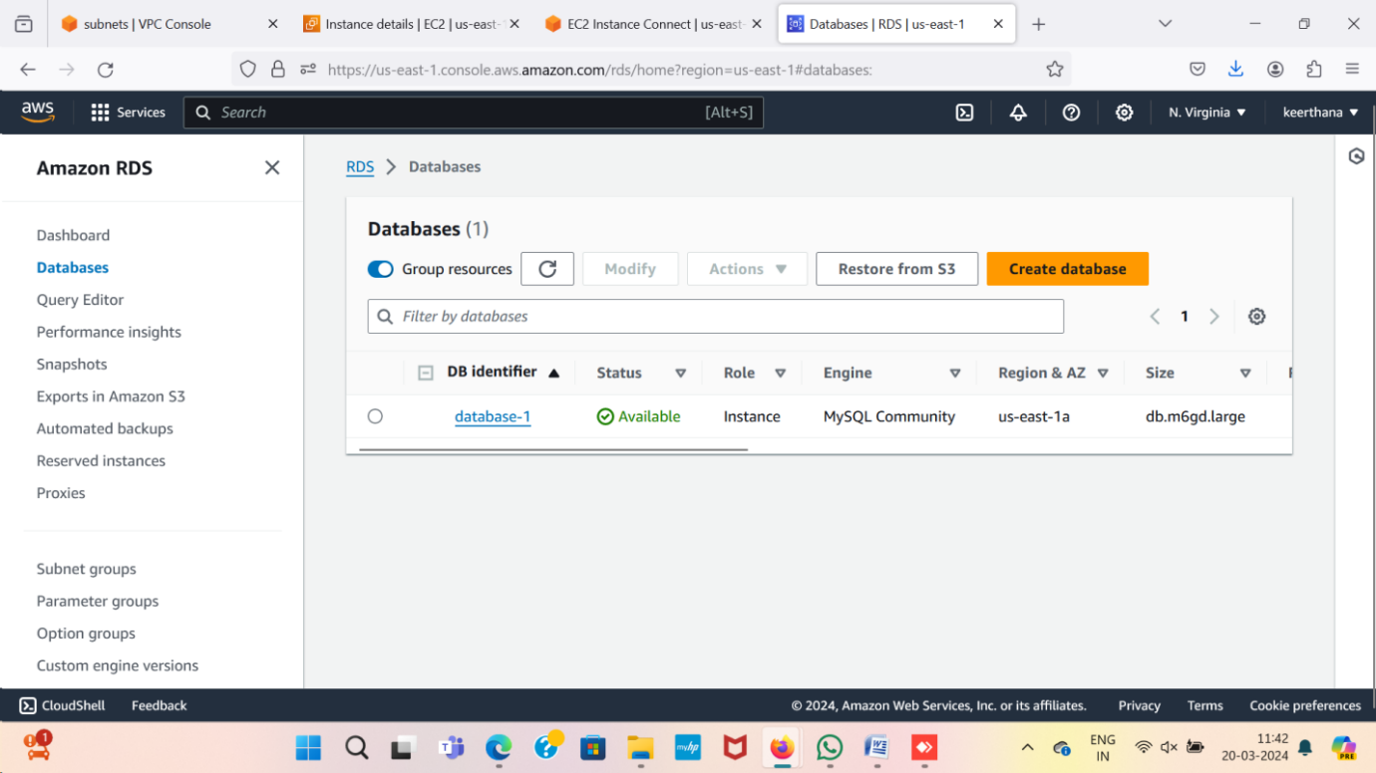

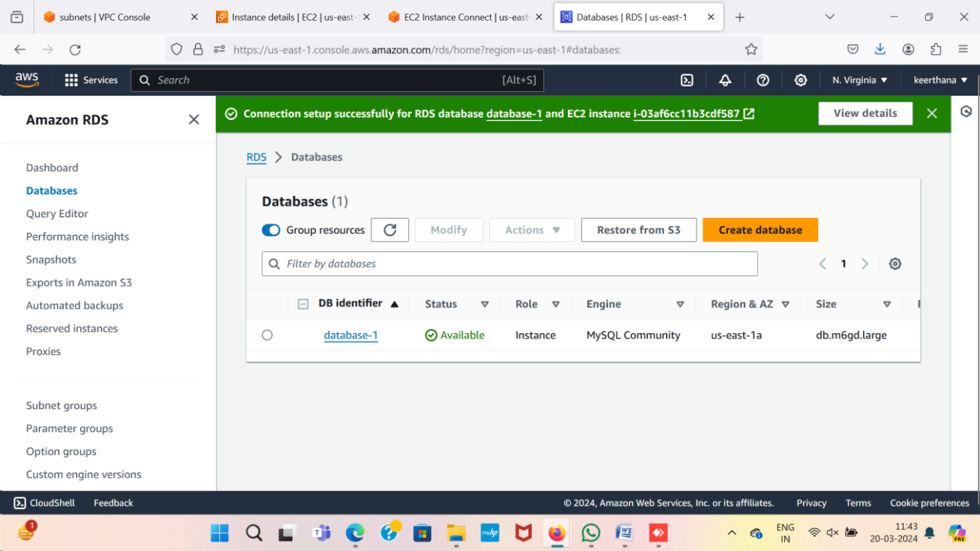

After Creating database go to ec2 instance then connect

Install mysql-server command is

sudo apt update –y

sudo apt install mysql-server

mysql –h <endpoint> -u <username> -p

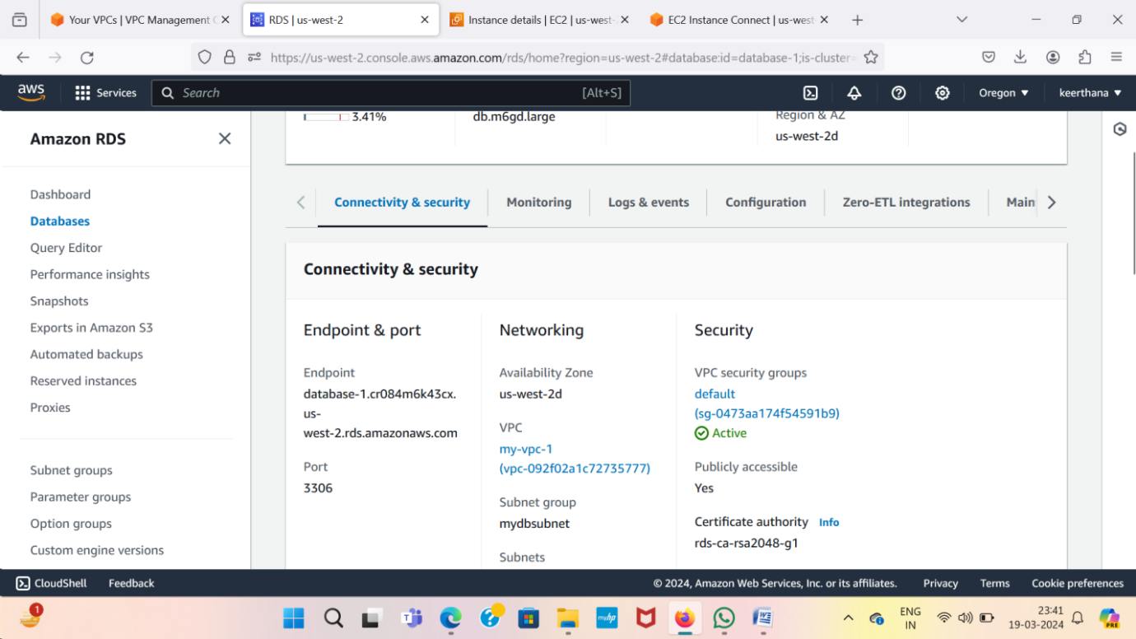

* Now we can see database connected to mysql server

